1.7 Handling File Uploads



This section will guide you to:

* How to upload the Desktop file in selenium WeDriver

**Development Environment**

* Eclipse IDE for Enterprise Java Developers Version Oxygen.3a Release (4.7.3a)
* JavaDevelopment Kit Version 8
* Selenium standalone server
* Autoit

This guide has mainly Two subsections, namely:

1.7.1 Handling File Upload by **SendKeys**

1.7.2 Handling File Upload by **AutoIT script**

1.7.3 Pushing the code to GitHub repositories

**Step 1.7.1:** Handling File upload by SendKeys

* Open Eclipse
* Create a project : Click on file->New->Java project
* Enter project name as UploadFile
* Click on Finish
* In the project explorer, Expand **UploadFile**
* Right click on **src** and choose **New->Class**
* In Package Name, enter **com.ecommerce** and in **Name** enter **Upload** and click on **Finish**
* Locate the browse button using chropath/firebug.
* Set the path using SendKeys. And the code looks like below

//Locating 'browse' button

WebElement browse =driver.findElement(By.id("uploadfile"));

//pass the path of the file to be uploaded using Sendkeys method

browse.sendKeys("D:\\SoftwareTestingMaterial\\UploadFile.txt");

**Step 1.7.2:** Handling File Upload by AutoIT script

* To open it go to **Start->Autoit v3->Autoit window info**
* Now drag the Finder tool box to the object in which you are interested

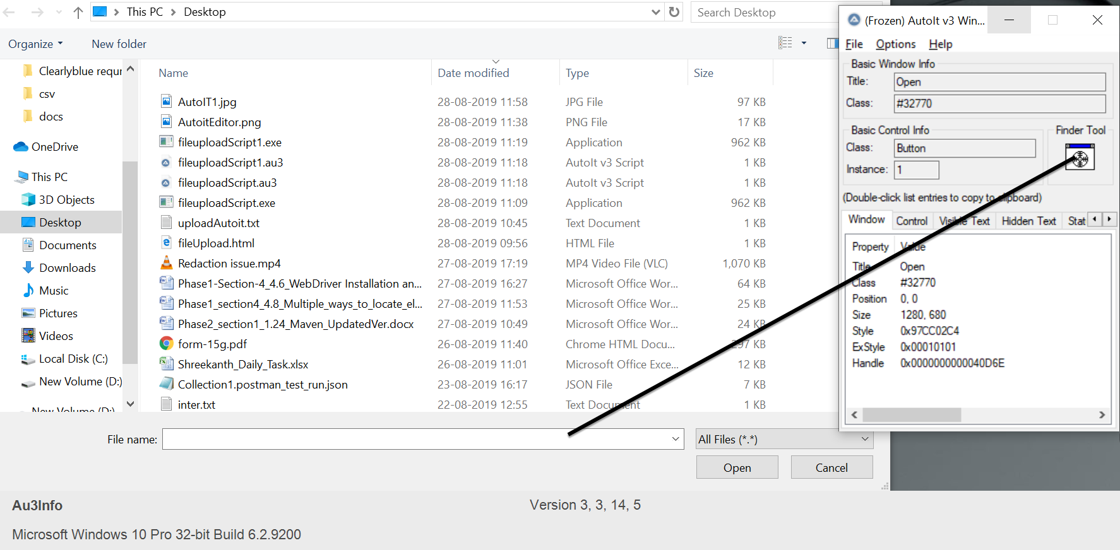

* Build an AutoIT script using **SciTE editor** and write the script using **ControlFocus, ControlsetText, and ControlClick** commands.
* And the script looks like below

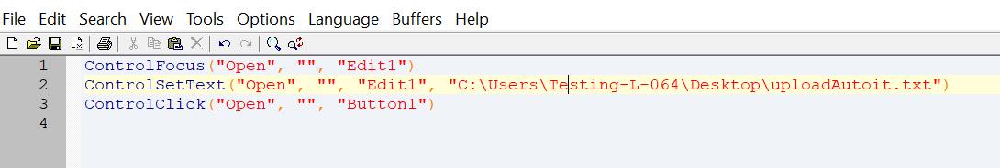

* Save the Script with **.au3** extension.
* Compile the **.au3** script which converts it into **.exe** file.
* Pass the **.exe** path into selenium test script using method

**Runtime.getRuntime().exec(“C:\AutoIt\Autoitscript.exe”)**

* Complete script looks like this

**import** java.io.IOException;

**import** java.util.concurrent.TimeUnit;

**import** org.openqa.selenium.By;

**import** org.openqa.selenium.WebDriver;

**import** org.openqa.selenium.firefox.FirefoxDriver;

**public** **class** AutoIt {

**private** **static** WebDriver driver = **null**;

**public** **static** void main(**String**[] args) **throws** **IOException**, **InterruptedException** {

driver = **new** FirefoxDriver();

driver.manage().timeouts().implicitlyWait(10, **TimeUnit**.SECONDS);

driver.get("http://toolsqa.com/automation-practice-form");

driver.findElement(By.id("photo")).click();

**Runtime**.getRuntime().exec("D:\AutoIt\AutoItTest.exe");

**Thread**.sleep(5000);

driver.close();

**Step 1.7.3:** Pushing the code to your GitHub repositories

Open your command prompt and navigate to the folder where you have created your files.

**cd <folder path>**

Initialize your repository using the following command:

**git init**

Add all the files to your git repository using the following command:

**git add .**

Commit the changes using the following command:

**git commit . -m “Changes have been committed.”**

Push the files to the folder you created initially using the following command:

**git push -u origin master**